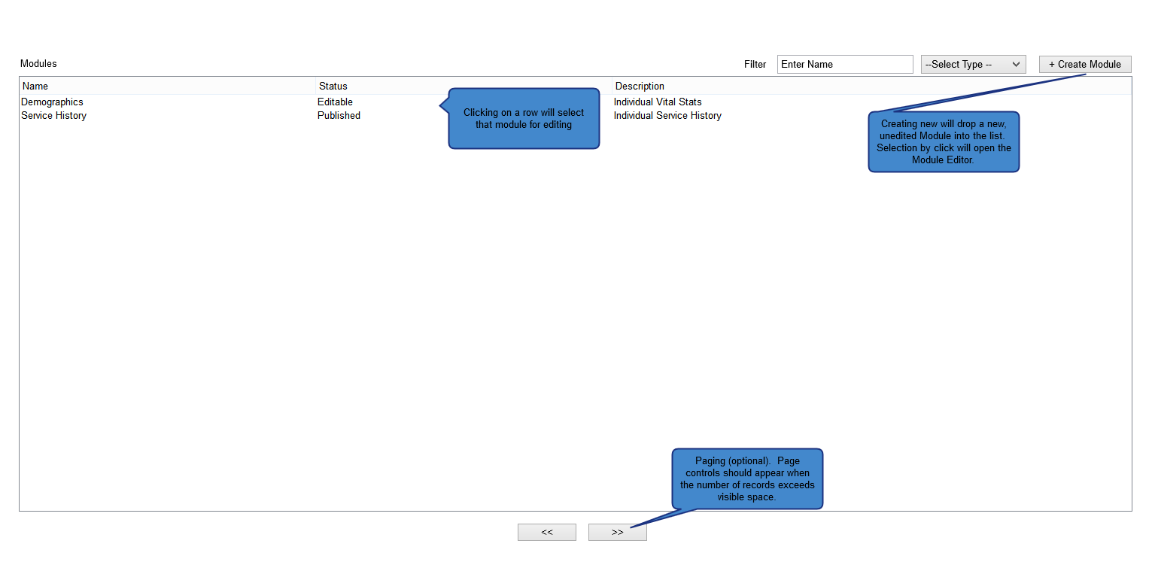

Figure 1: Module List View

* This is the initial view the user is taken to when selecting the Module Editor. The user has the ability to view all Modules, filter the listing by Name and Status (the Name filter is a typeahead search).
* The user can contextually select a Module for editing (by inline button), or delete Modules that are in an unpublished (Editable) state, or create a new Module (via the Create Module button).
* Selection of a new Module, or to Edit an existing Module navigates the user to the Module Editor View.

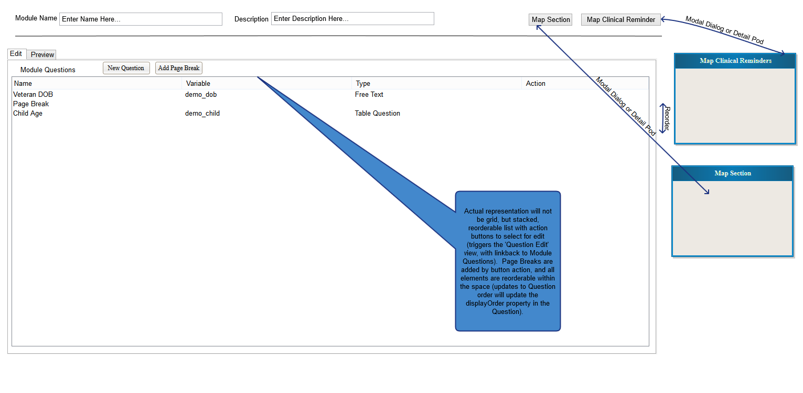

Figure 2: Module Editor View

* The view is a top-down view of the Questions composing the Module, with context navigation providing access via modal to map Sections, Clinical Reminders, add Page Breaks by drag and drop operation, reorder questions via drag-drop sort, and a Preview pane to navigate the result and/or refine the Question Order for the Module.
* Questions can be selected and edited/removed via inline buttons (Edit and Delete), or added by clicking New Question. Clicking New Question will allow the user to select the Question Type (eg., Free/Read Only Text, Select Single, etc.), and will navigate the user to the specific Question view for editing. The user will have the ability to reselect the Question Type in the Question View, if an error was made, reflowing the view for the user with the specific properties and structure for the Question Type selected.

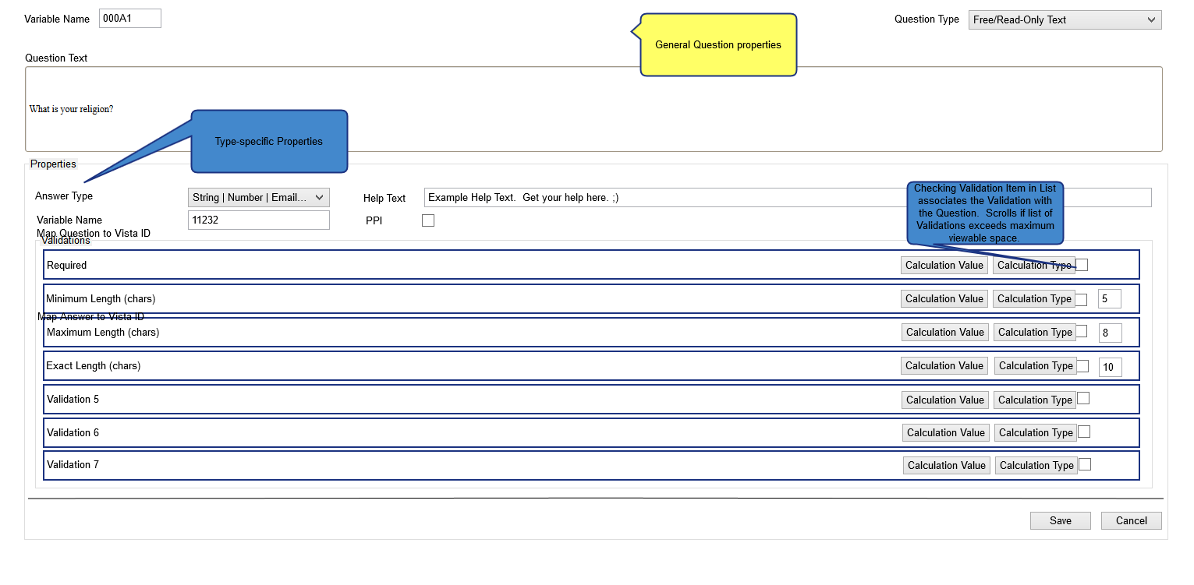

Figure 3: Free/Read Only Question View

* In the Question View, the user has control of which Question Type is selected, the editable properties of the Question itself, the ability to define Answer(s) to the Questions, reorder Answers, edit the Question Text, Help Text, assign Variable Names, and select PPI.

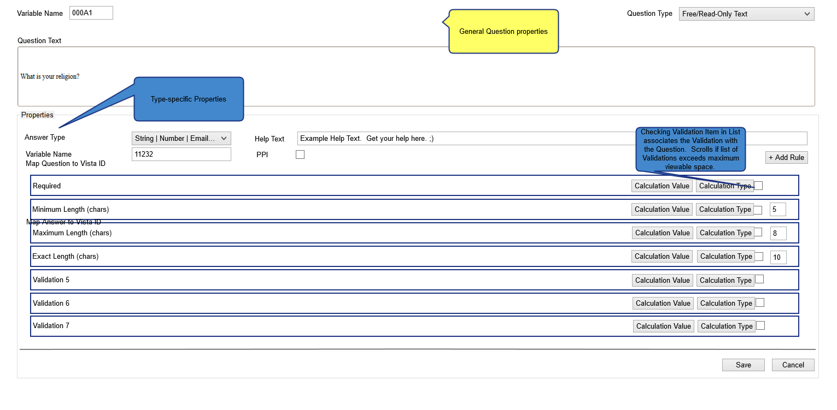

Figure 4: Select Single/Multiple Question

* Given similar structure, the user can select the specific type (Single or Multiple) after selecting the Select Single/Multiple Question Type view.

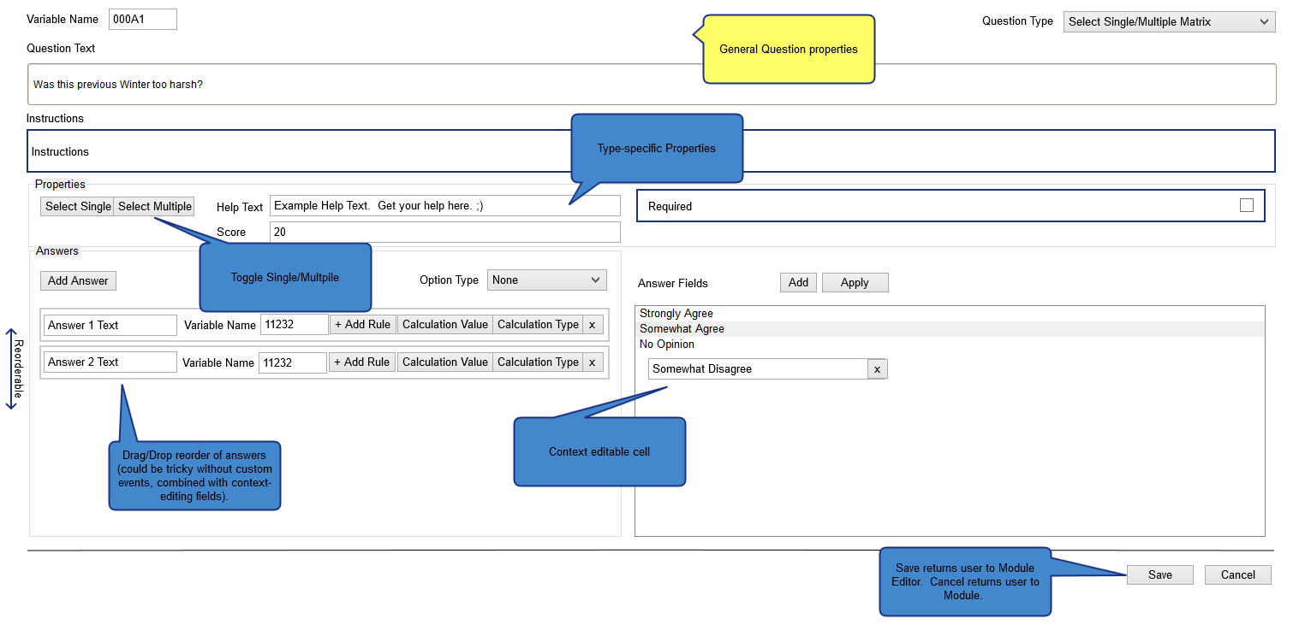

Figure 5: Select Single/Multiple Matrix

* As with Select Single/Multiple, the user can select specific type, with specific properties to the Question Type provide on selection.

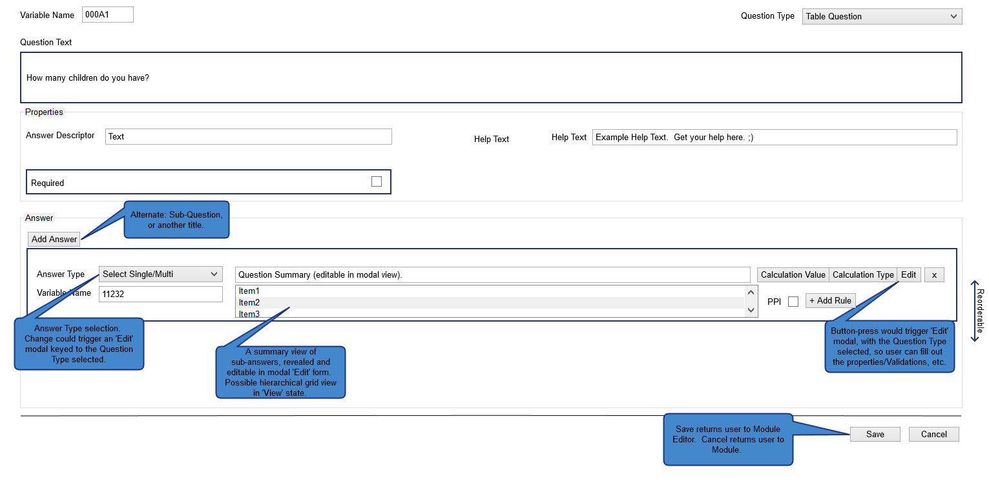

Figure 6: Table Question

* Table Questions are the most complex types, as the Question Type is composed of many Answer Types. As Answers are added, the Type selection will bring up an Edit modal that is representative of the Answer Type (Free/Read-Only Text, Select Single, etc. – in essence the Question Type view for the Type selected) to allow granular edits of the Answer’s properties. Answer Types that have nested Answers of their own will be viewable by inline hierarchical grid, collapsed until the user selects it. The Answers section will be provided on creation with an Instructions type, for editing, by default.

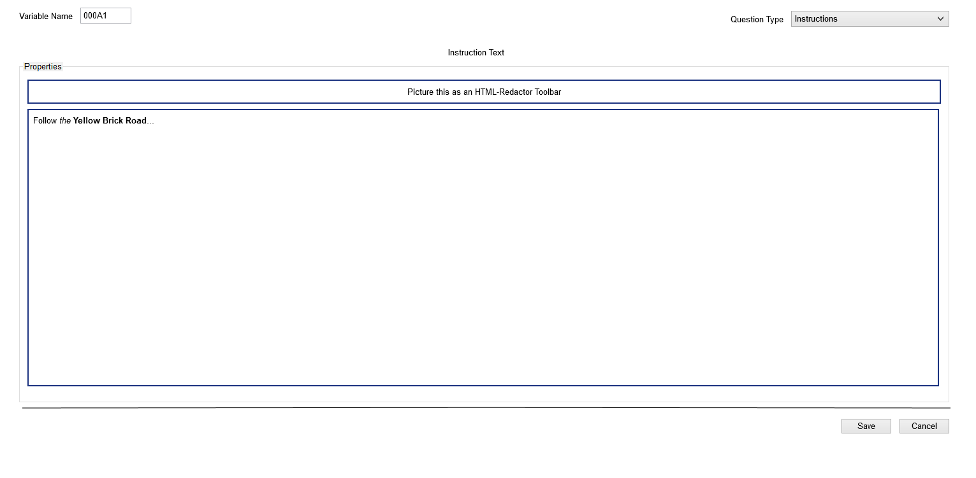

Figure 7: Instructions

* Instructions is the simplest type. The user will be presented with the ability to define the Instructions text via HTML Redactor control, allowing WYSIWYG editing of the question text.